Name: Pranali Sonawane
Subject: MCSA
Date: 22-12-2025
Lab 16: Backup
Server 1:
Download Windows Server Backup: Add roles and Feature next next Select Windows Server Backup next install.
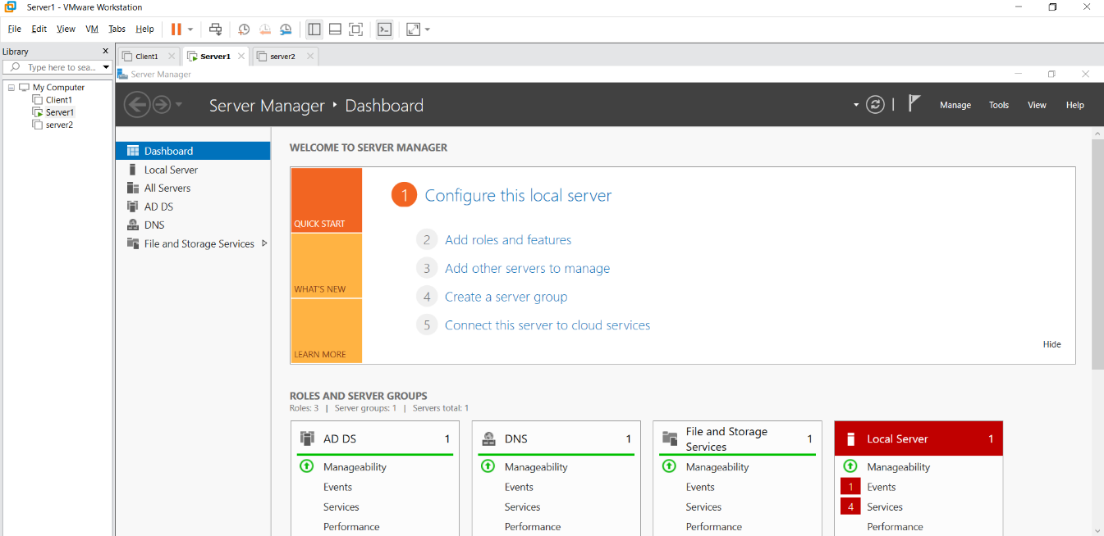

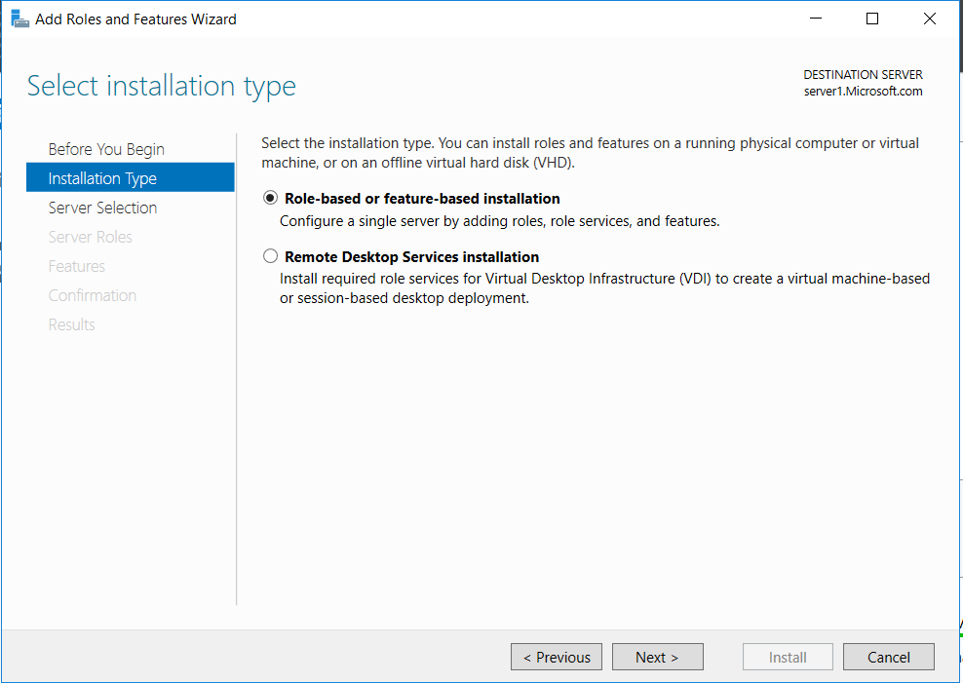
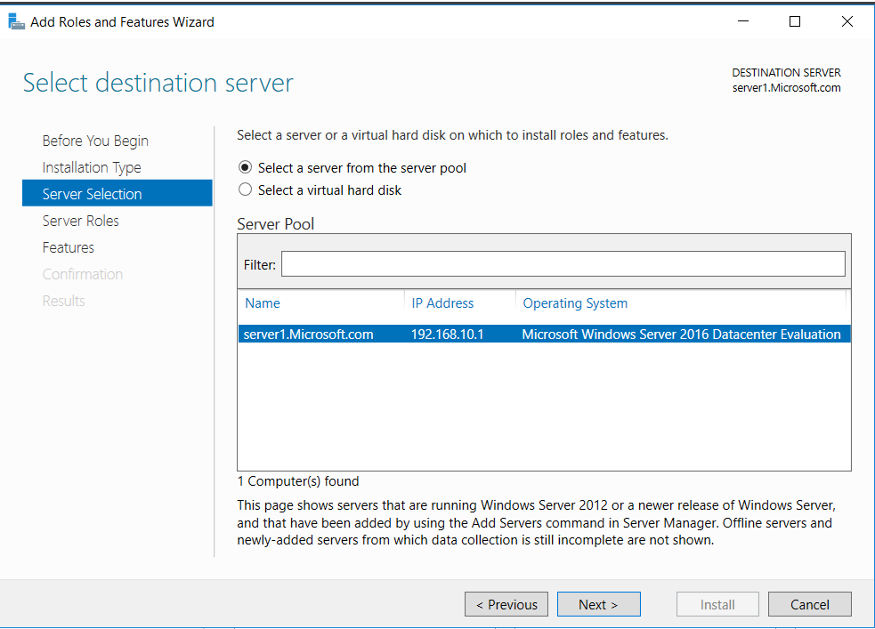
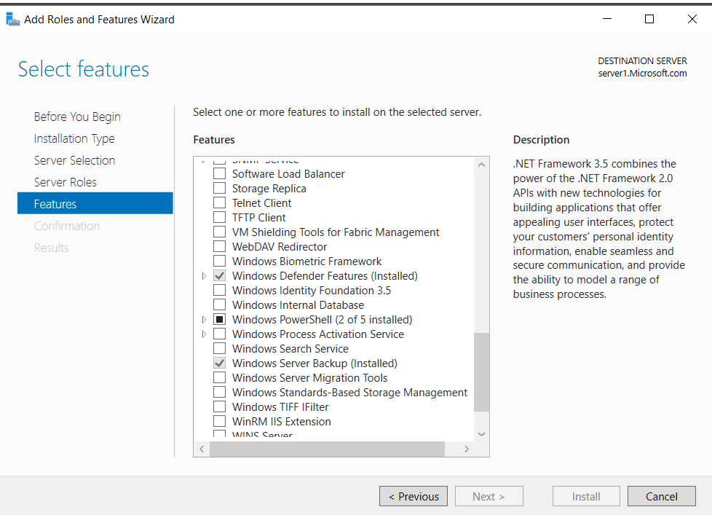
This PC: Create E Drive also
Add in C drive create folder test in that create abc.text
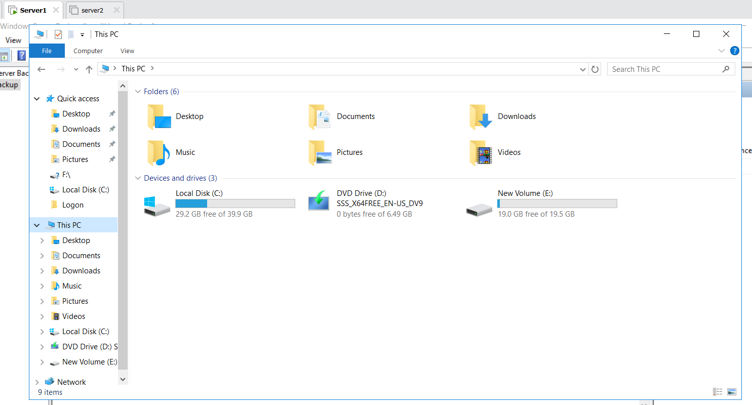
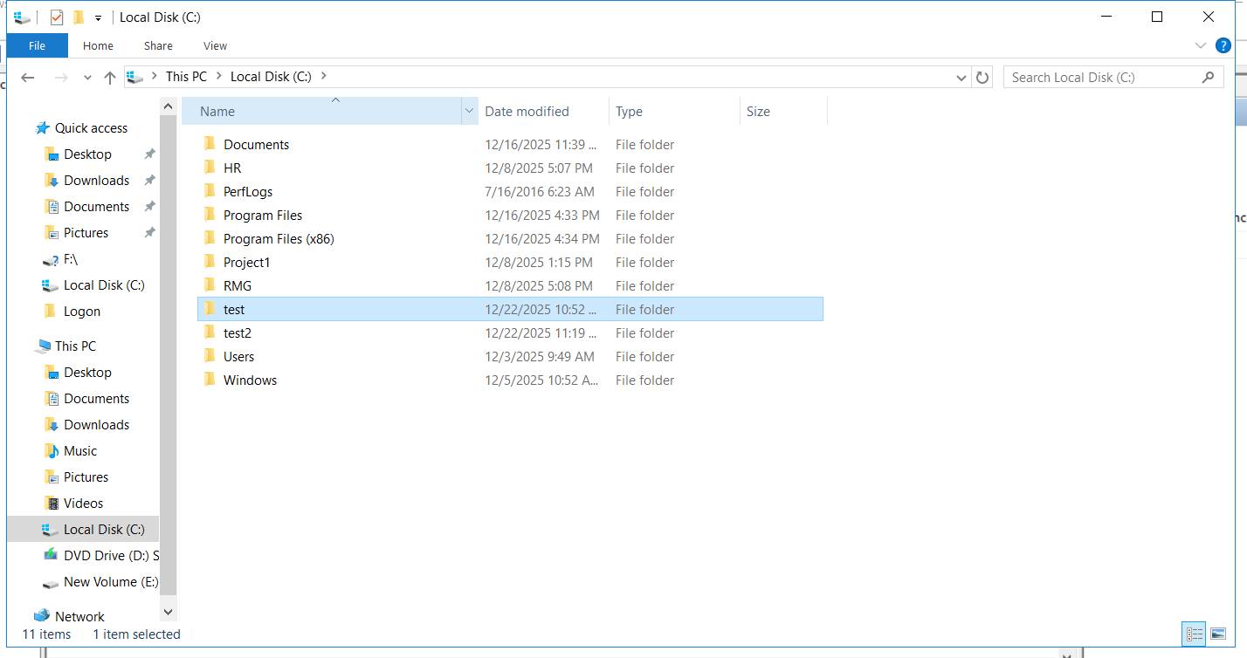
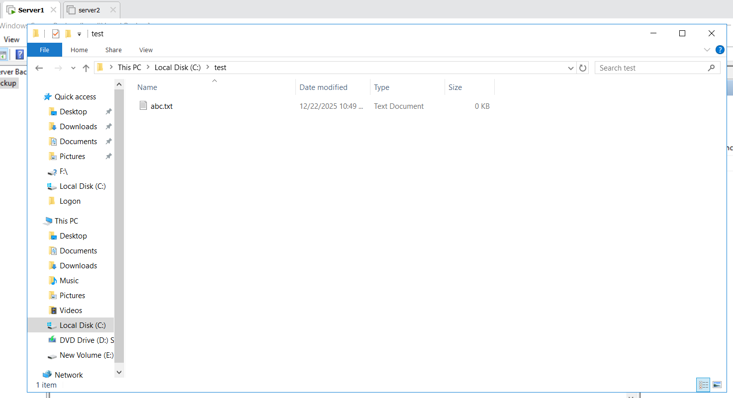
Windows Server Backup Local Backup Backup once Custom select C: test Local Drive next Backup
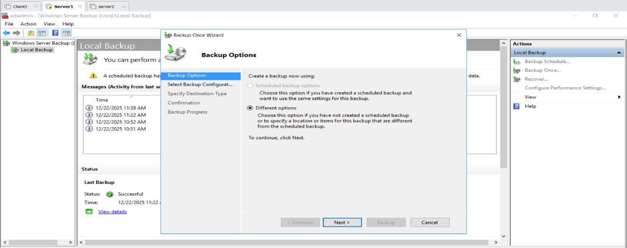
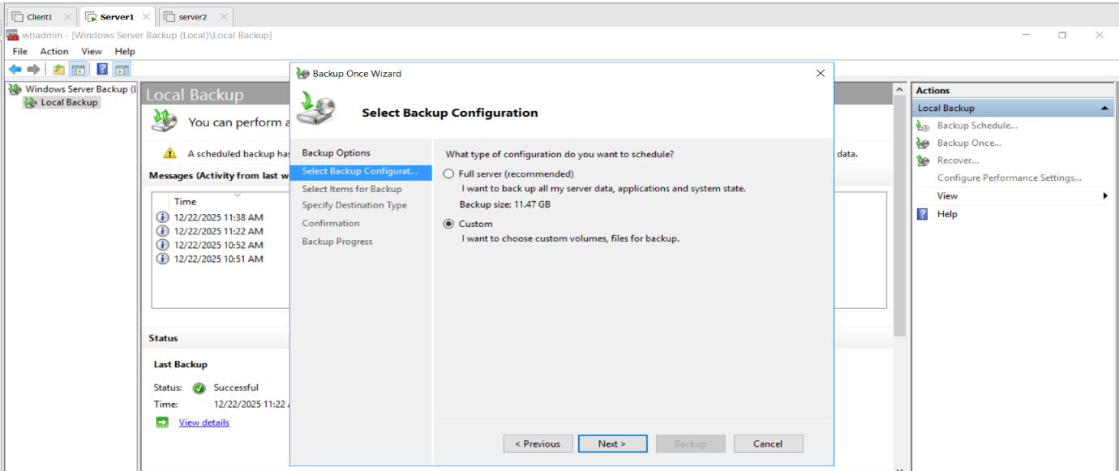
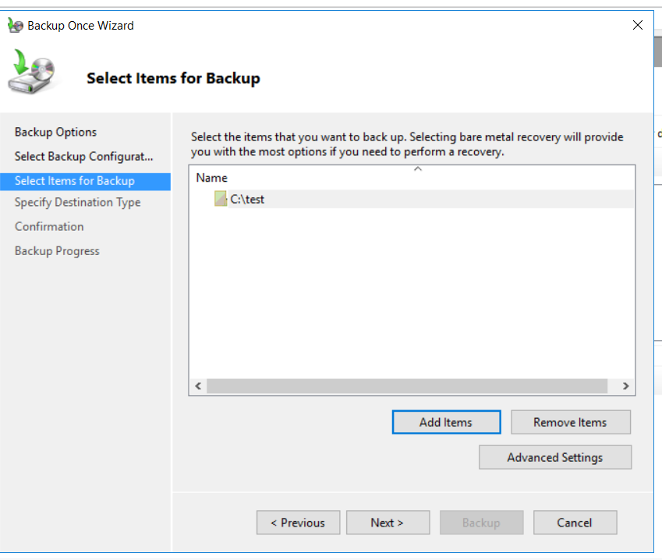
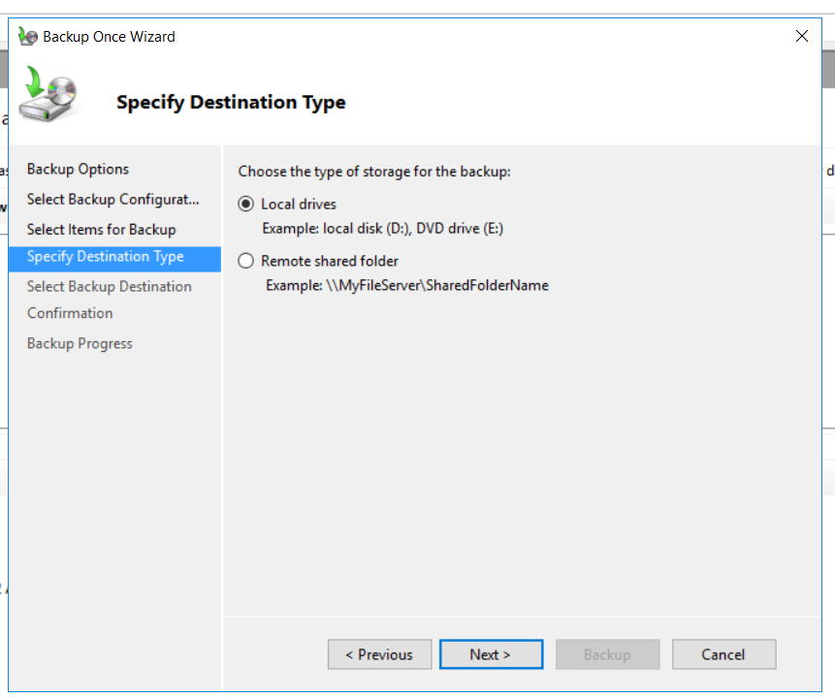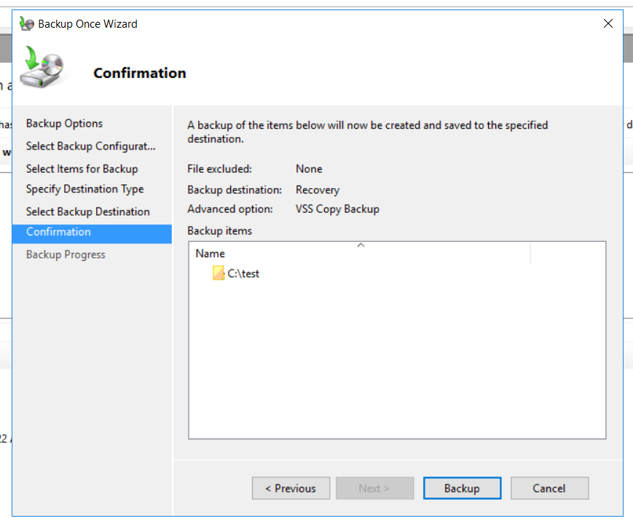

In E Drive Check
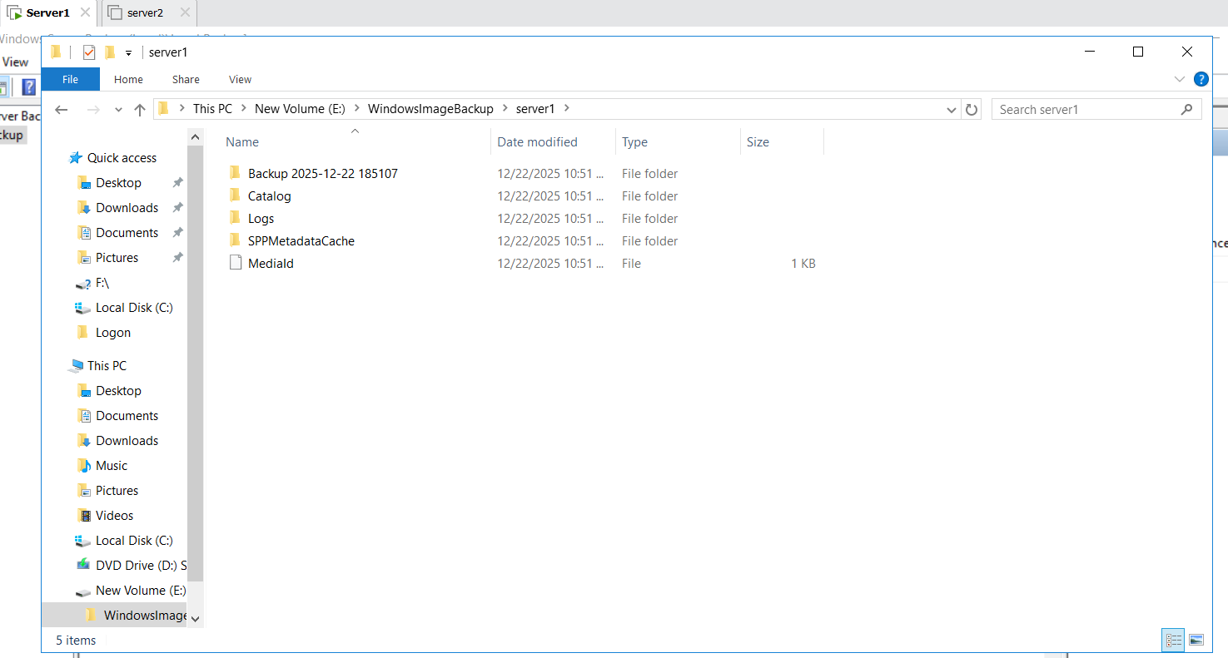
In C Drive delete test Folder
Windows Server Backup Local backup recover next File and Folder next Original Location Recover
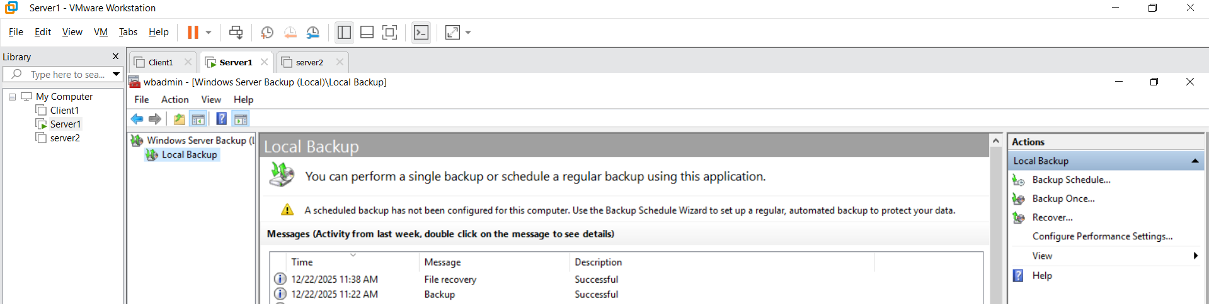

Task : Backup Recovery after delete Folder on server 1 it’s should be recover on server 2
Server 1 :
Create a new Folder Folder test2
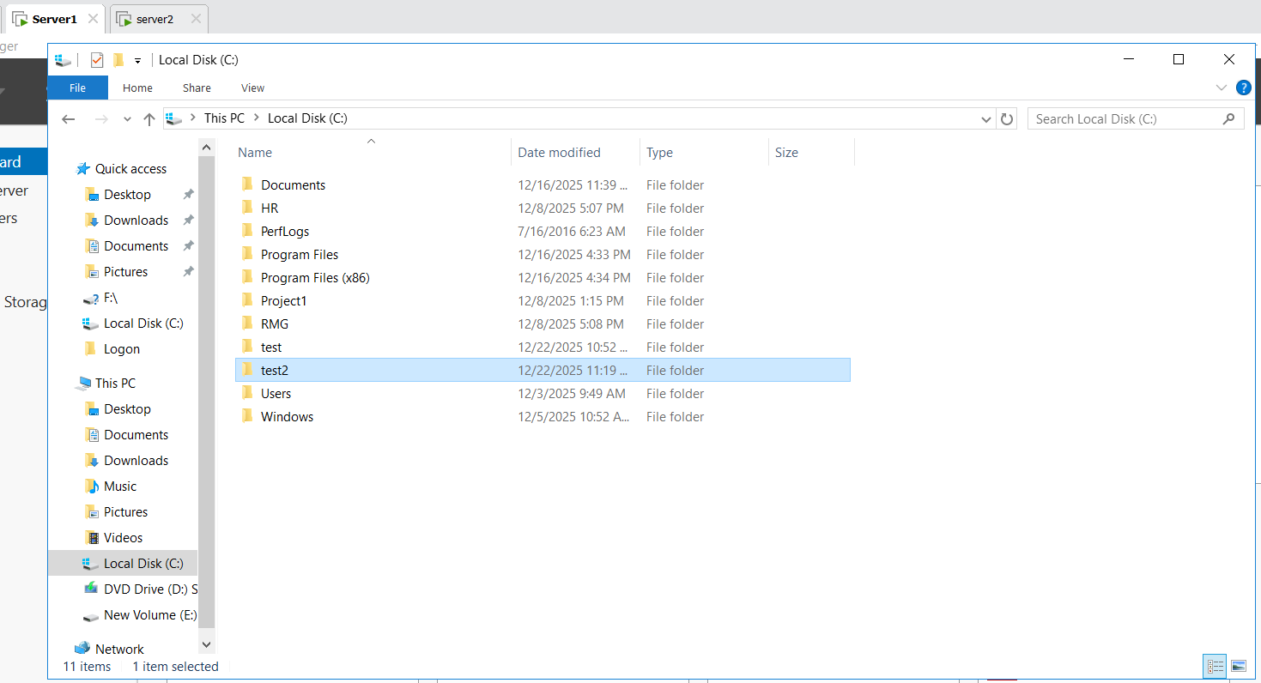
Server 2:
C Drive create backup Folder give backup folder sharing Permission Full Control and also Security Permission Users full Control

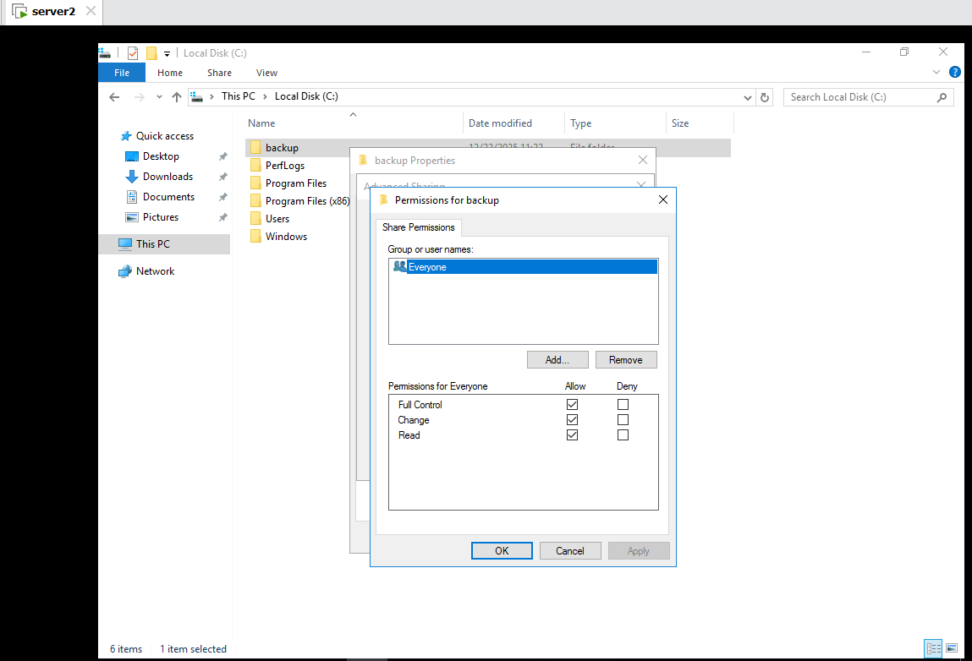
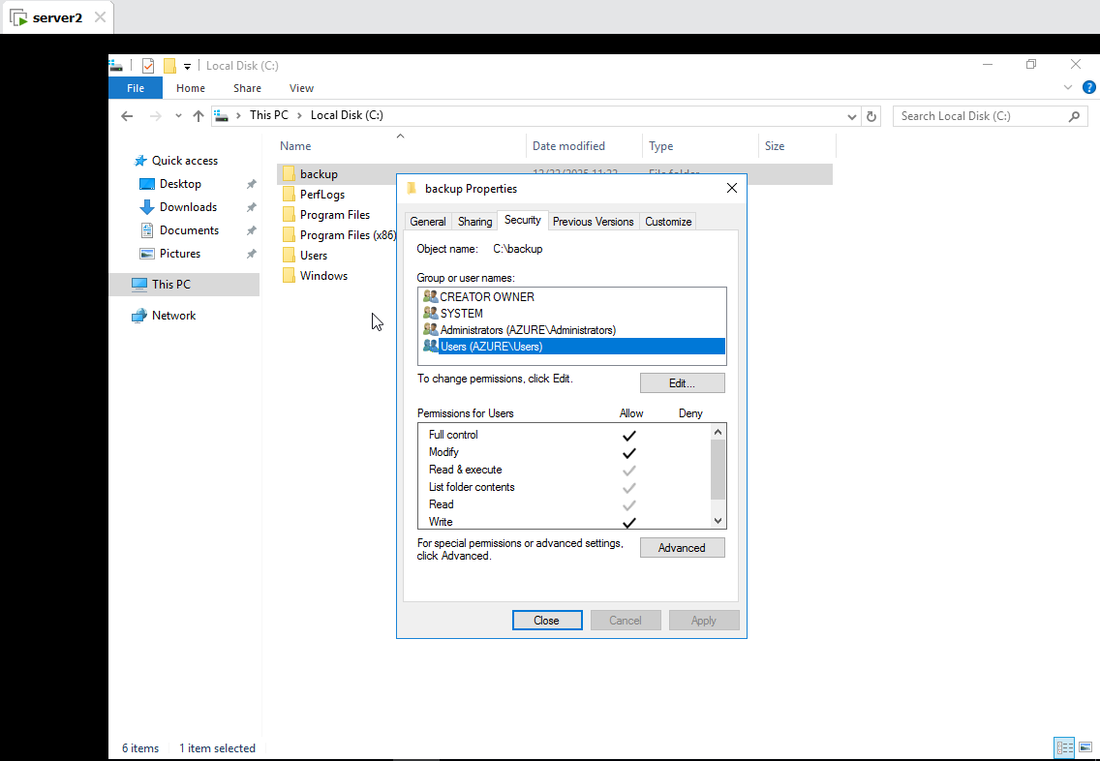
Server 1 Windows Server Backup Local Backup Backup once Different Options Remote shared Folder Give Location \\server2\backup Backup
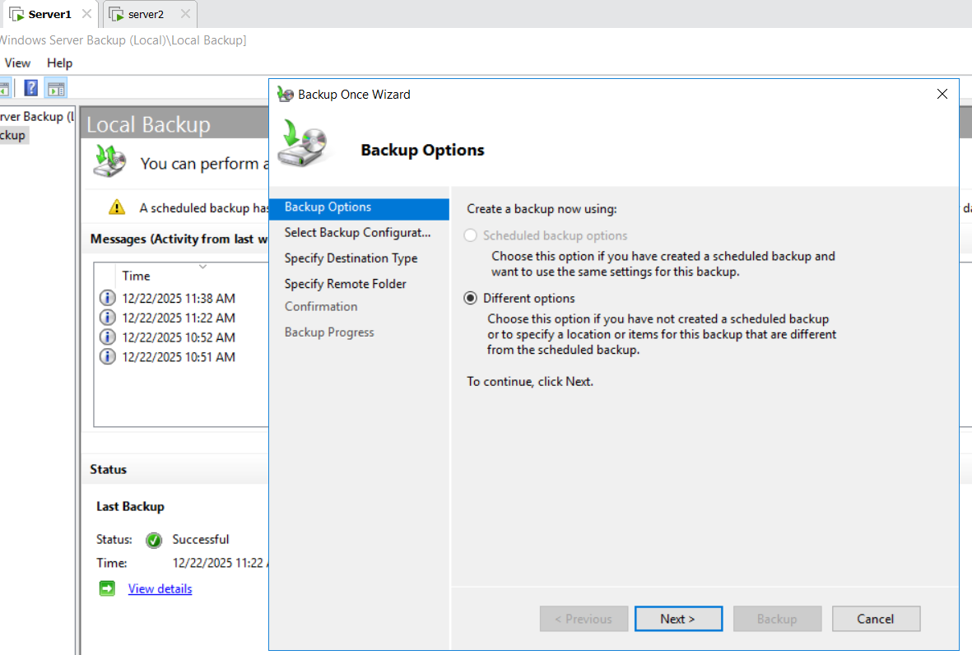
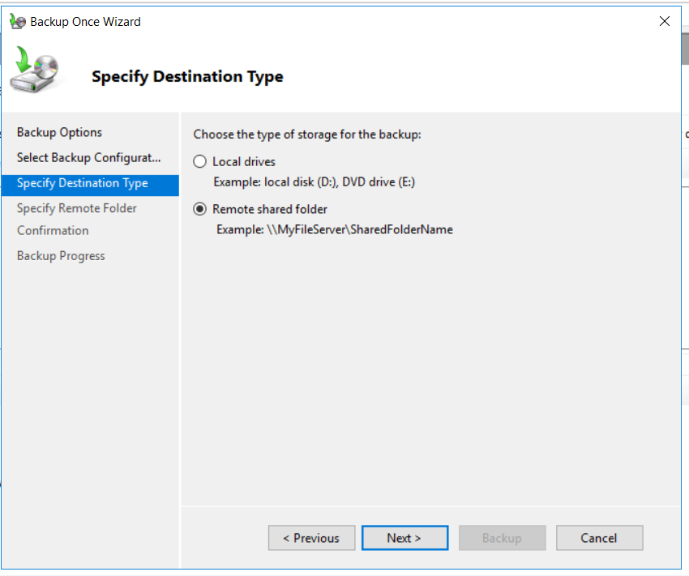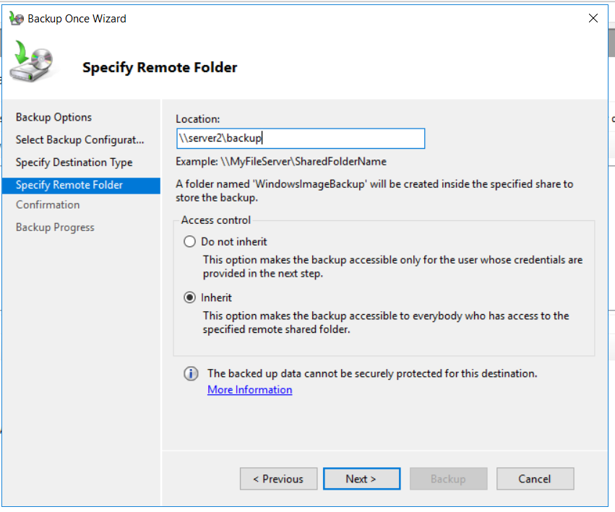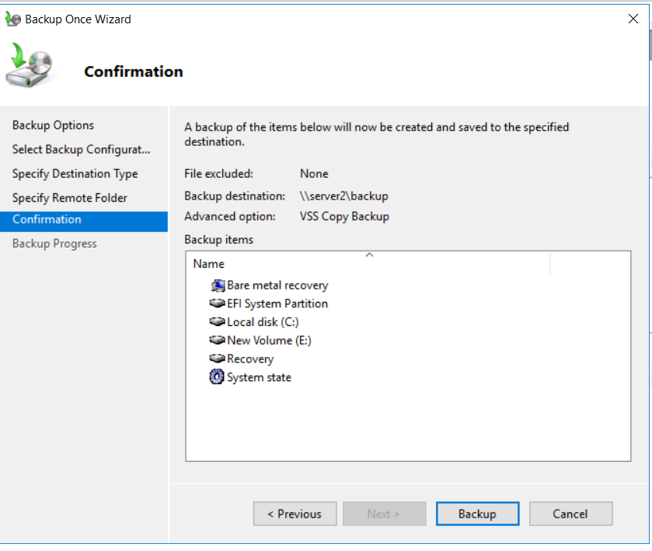
Server 2 :
This PC C drive backup Folder WindowsImagebackup Server 1 (Present backup of the Server 1 )
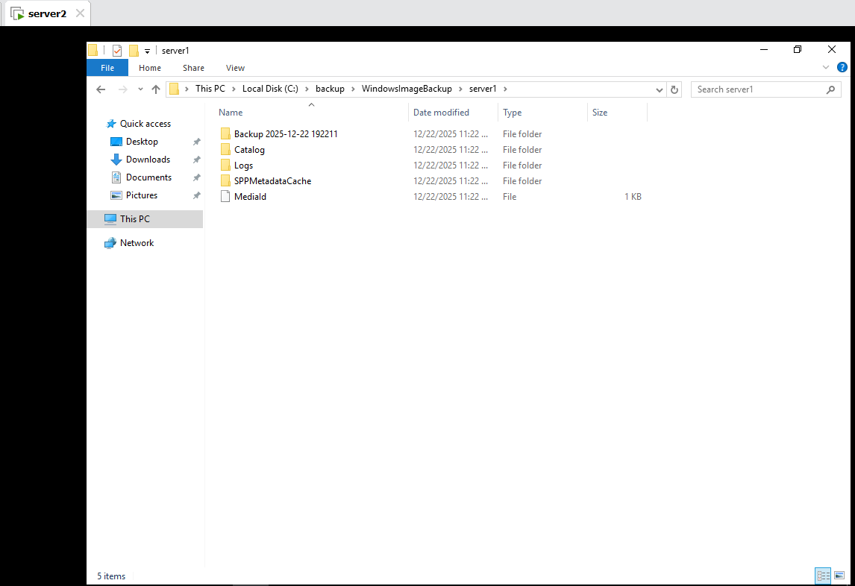
Server 1:
In C drive delete test2 folder
Tools Windows Server backup local Backup Right click on Recover select This Server 1 next Files and Folder Server 1 Local Disk (C) next Another Location Browser select C drive Recover
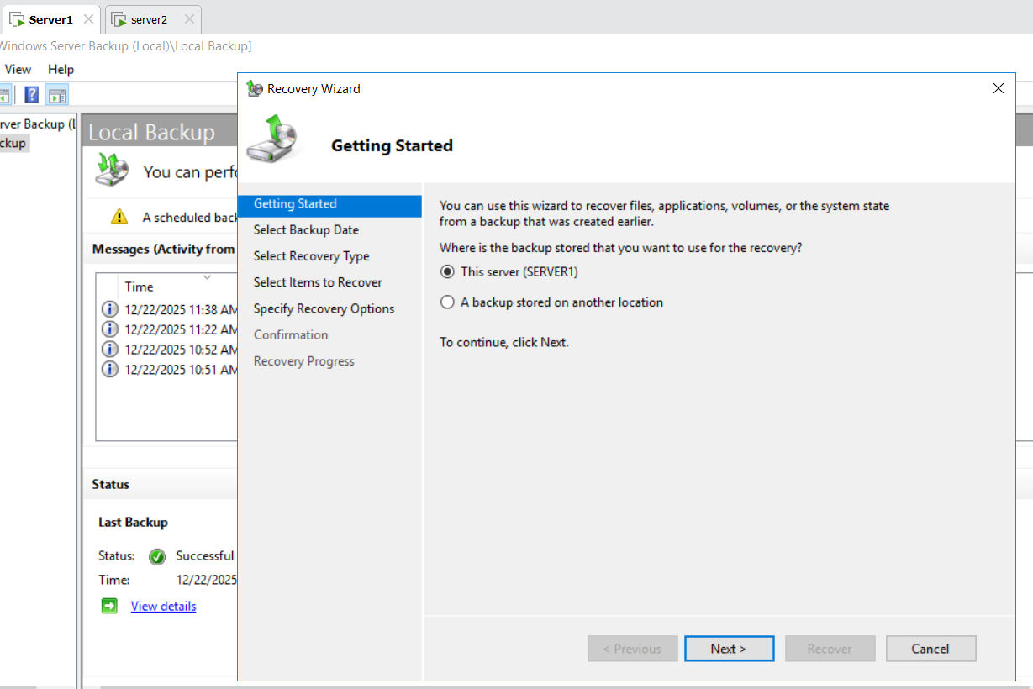
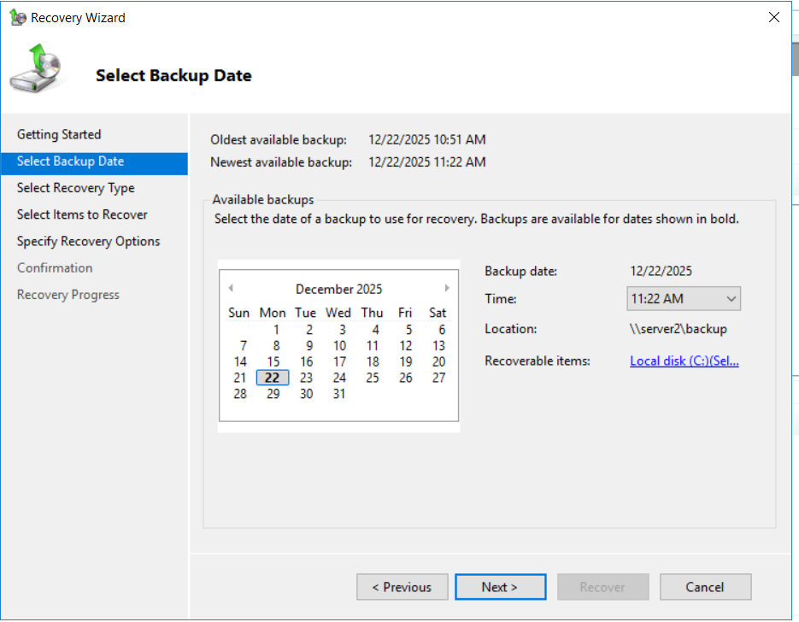
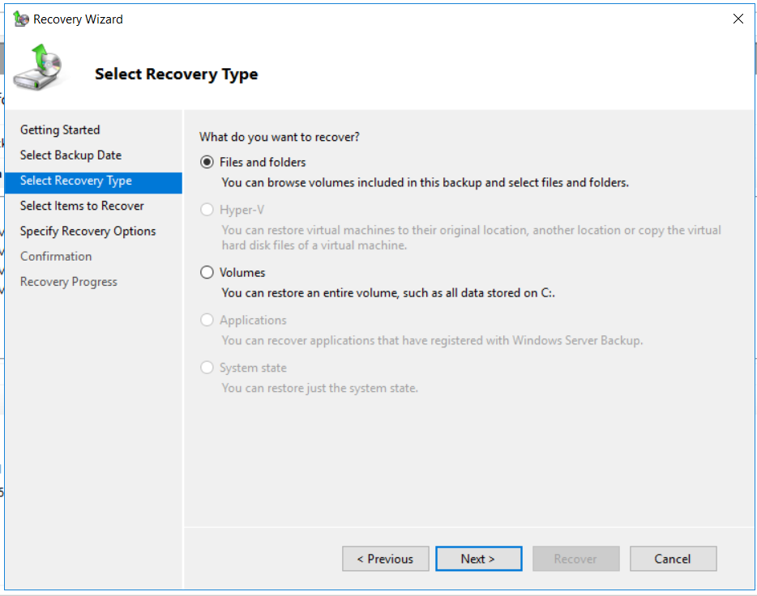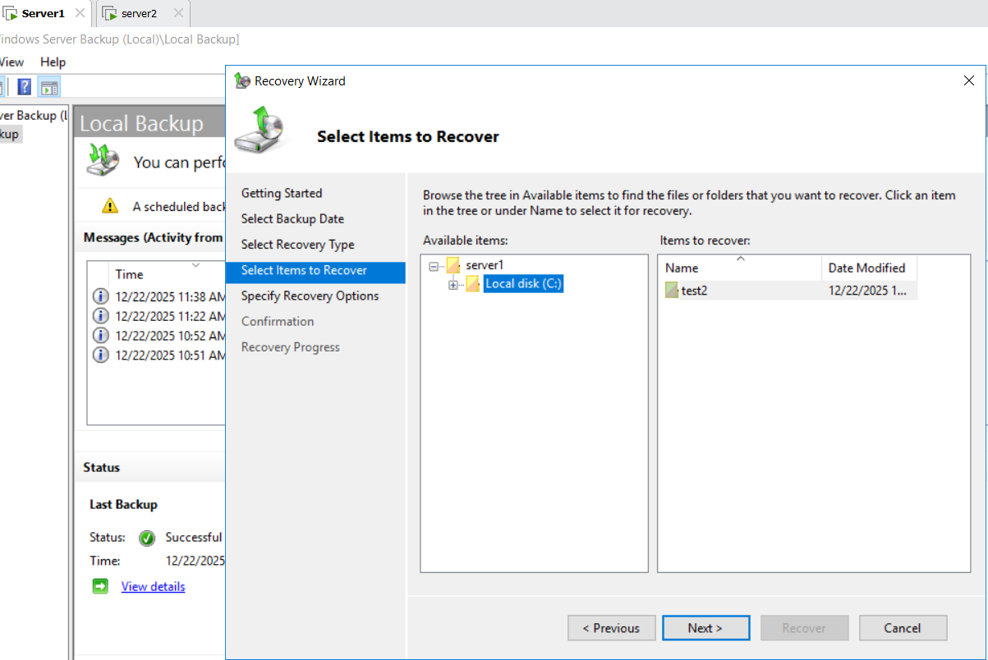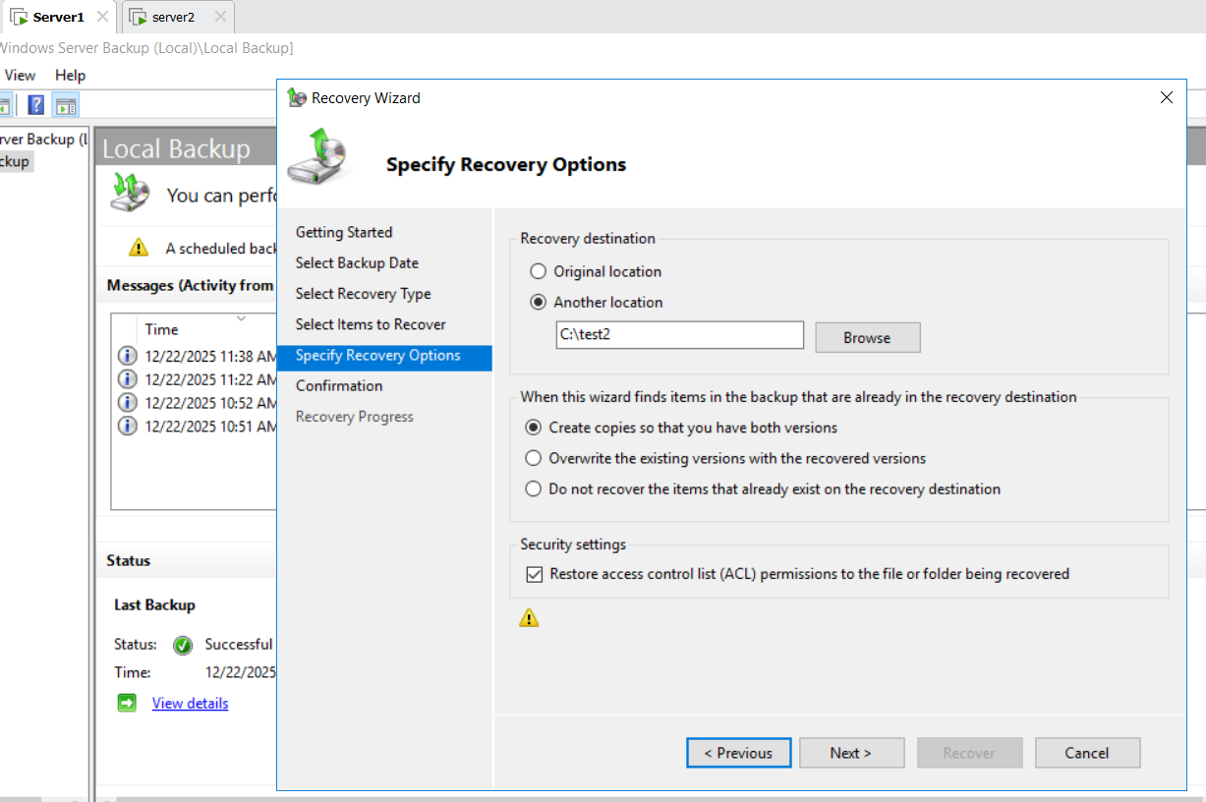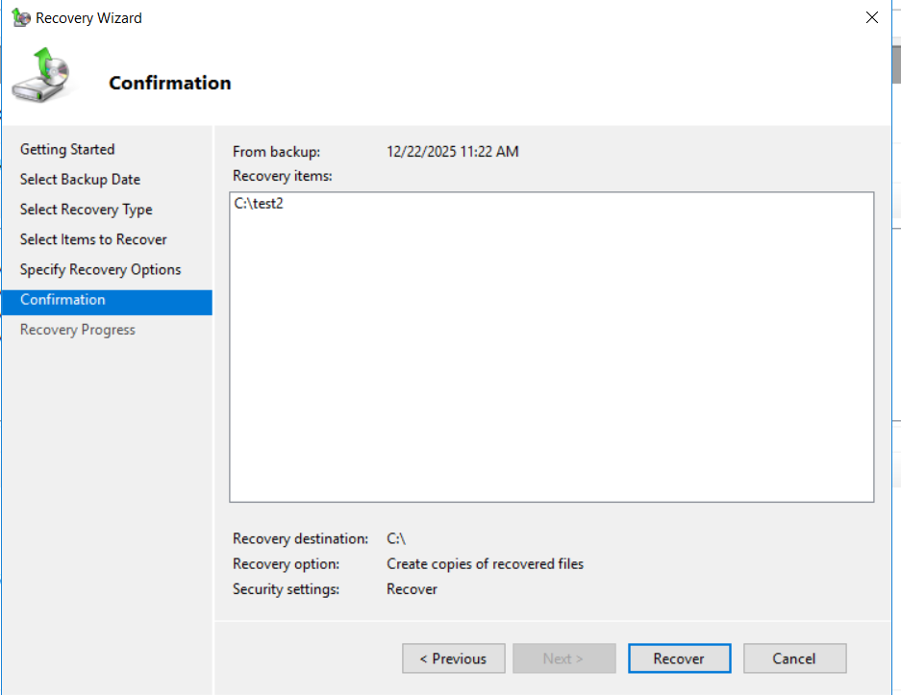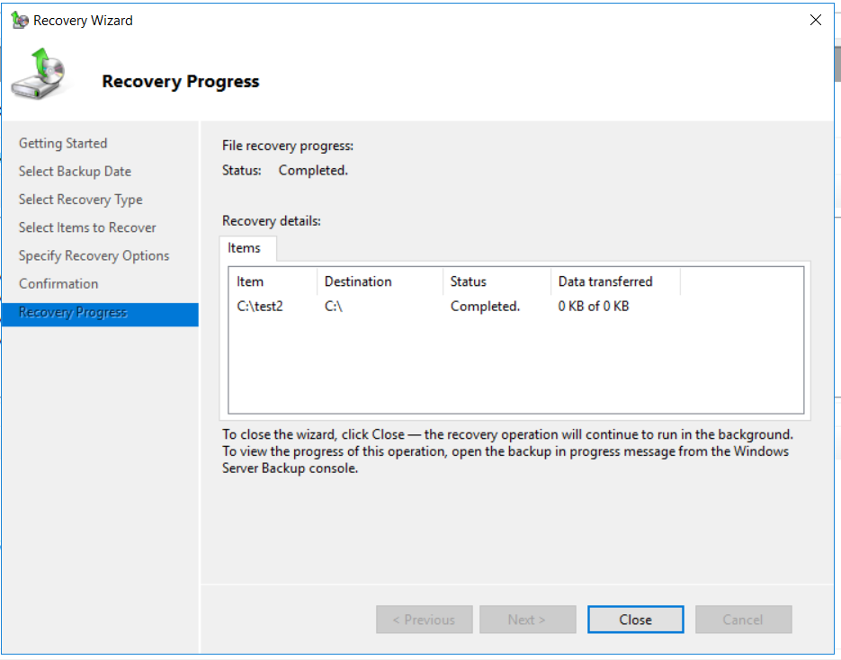
In Server 1 C drive test2 is Recover
